JAVA LENGTH OF LINE PROGRAM LAB REPORT
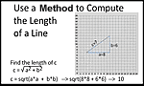
Name and Student ID: Jibran Akhter - 1073973
Date project completed: 3/20/2024
Platform (Mac, PC, Linux, etc.): Windows 11 PC
Development system (onlineGDB, NetBeans, Eclipse): online GDB

OBJECTIVES
Organize the Java program placement that contains a main method and a function method
Analyze project definition and create a program based on the definition
Implement a Java method to compute the length of a line
Compute and Display the length of a line based on two X,Y coordinates

PROJECT DESCRIPTION
Create a program that uses a Java method to determine the length of a line by inputting the X,Y coordinates of the line endpoints. Show the result with a precision of four decimal places. The declaration of the method is to be:

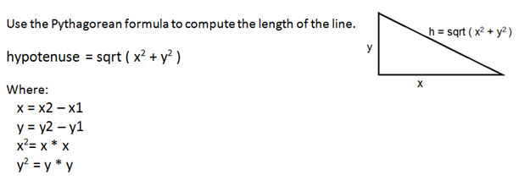
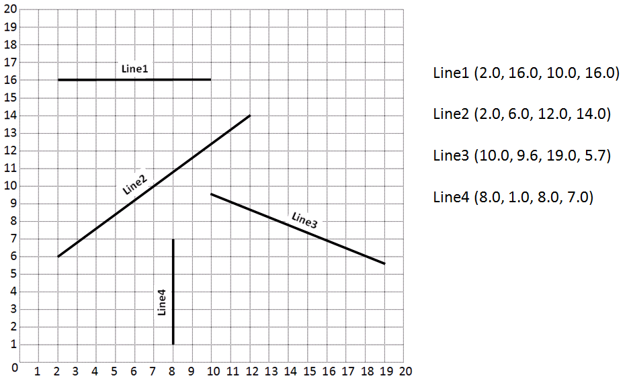

TEST DATA TABLE
Use a calculator to compute the Expected Results
Fill in the Actual Results after you have run and tested your program. No screenshots.
TEST DATA VALUES | EXPECTED RESULT  Computed values before the program is run | ACTUAL RESULT  Fill in the output displayed  by the program
2.0 16.0 10.0 16.0 | 8.000 | 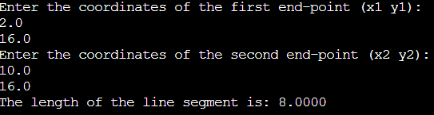
2.0 6.0 12.0 14.0 | 12.8062 | 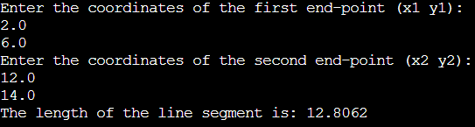
10.0 9.6 19.0 5.7 | 9.8087 | 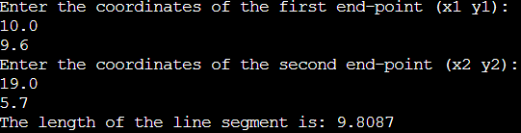
8.0 1.0 8.0 7.0 | 6.0000 | 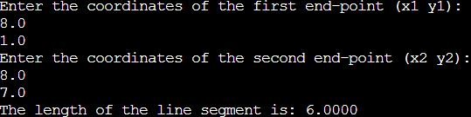

DISCUSSION
What did you do to develop the program? ("Followed the Directions" is not a complete description

I began by thoroughly understanding the project requirements, which was to calculate the length of a line segment based on two sets of X and Y coordinates. After grasping the task at hand, I used the hint for the structure of the program. I proceeded to write the Java code, implementing the program's functionality as per the outlined structure. Testing played a crucial role in ensuring the program's accuracy; I input various sets of coordinates to verify that the length of the line segment was calculated correctly.

What problems did you have and how did you overcome the problems?

I did not encounter any problems during the development process since I had a clear understanding of the formula required to calculate the length of the line segment. My familiarity with the mathematical concept and the implementation of the formula enabled me to proceed smoothly with the coding process.

SCREENSHOTS
Capture only the portion of the screen that shows the calculator or program output. Do not capture the entire screen even though it may also contain the program output. If I need to zoom in on a screenshot, sometimes the image resolution is so poor that I am not able to read it. If this happens, I will ask that you resubmit your lab report. Refer to these instructions capturing screenshots and pasting them to the lab report

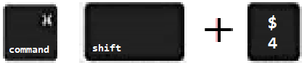
For the Mac
- hold down command + shift keys and press the 4 key
to get a screenshot of a selected area of the screen

- Use the mouse or touchpad to select the desired area of the screen you want to save
- use command+V to paste into the lab report

For Windows

- use Microsoft's Snipping Tool by holding down the
Windows and Shift keys and tapping the ‘S’ key

- Use the mouse or keypad to select the part of the screen you want to save
- use Ctrl+V to into the lab report.

Paste four screenshots here, one screenshot showing the program execution for each of the four lines

